**Project 9: Advanced Shaders 1**

Asher Shores, Cameron Verini, & Ryan Woodward

College of Science, Engineering, and Technology, Grand Canyon University

CST-310: Computer Graphics Lecture and Lab

Dr. Isac Artzi

August 5, 2022

**Background, Concepts, Aesthetic Decisions**

For development of the this project it required rudimentary comprehension of shaders, their purpose and utility, and familiarizing ourselves with Unity. Although all of the shaders used were provided in class or predefined in within Unity it was an excellent introduction to the variety of capabilities availble with developing projects with Unity. Significant to working with shaders is the portions of the shaders that we were guided through editing in class. For instance the properties declared, such as color or texture, relate to the uniforms and attributes coded within the HTML scripts for WebGL. Furthermore fragement and vertex shaders are also incorporated in the shader files this is done by using statements beginning with ‘#pragma’. Aside shaders we also included a camera that rotated around the scene to demo some of the shaders implemented. This was handled through the unity hierarchy and brief C# script. This project largely began as an experiment to learn Unity’s environment, other than exploring the possible and the creative there was little planned decisions behind the look and layout of the scene.

**Shaders, Models, and Textures**

Creation of the scene for this project consisted, largely, of incorporating predefined models, textures and shaders. Models were obtained from resource websites such that had pre-frabricated models. Attaching specific textures and shaders was done after importing the models from the internet. Within this project each of the described shaders in class were implemented. Among these were the CG, surface, normal mapping, holographic, transparent, and UV scrolling. The screenshots below showcase the implementation of each of the seven shaders from class.

**Screenshots**

***Holographic Shader***

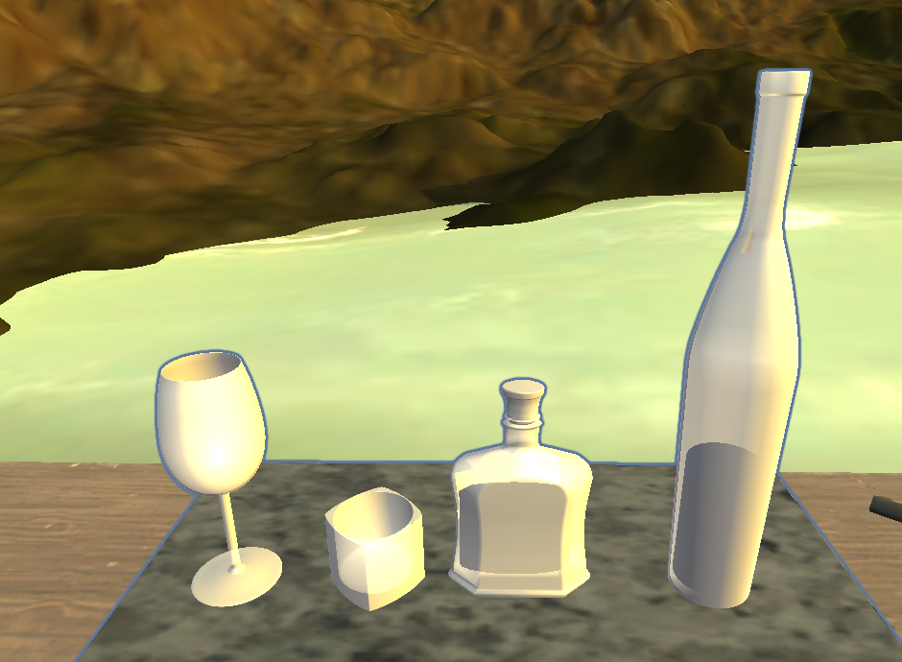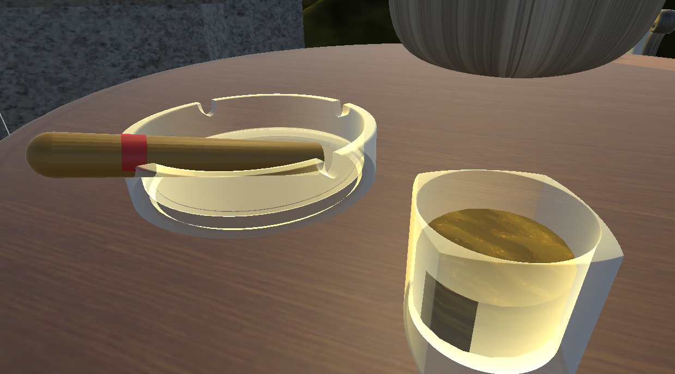

***Normal Mapping Shader***

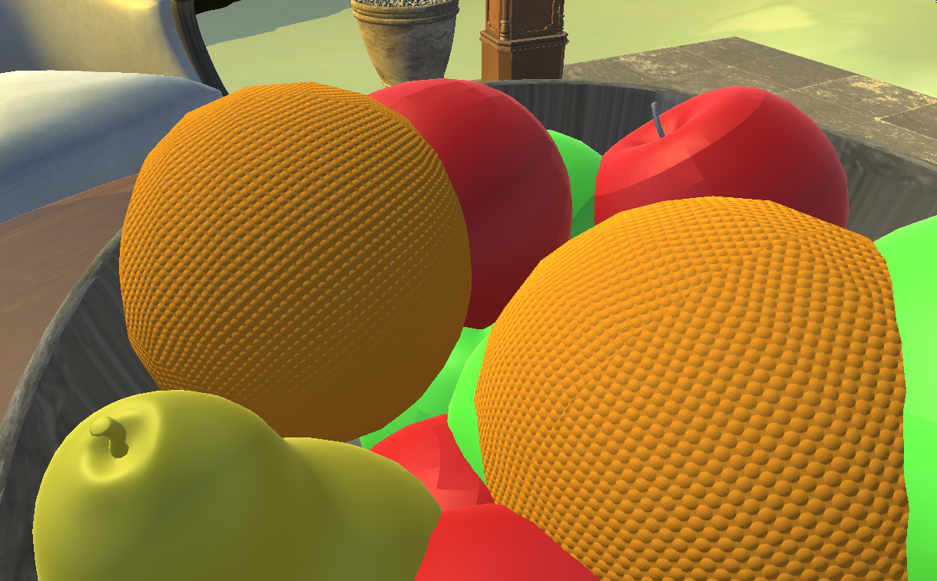

**Texture Blend Shader**

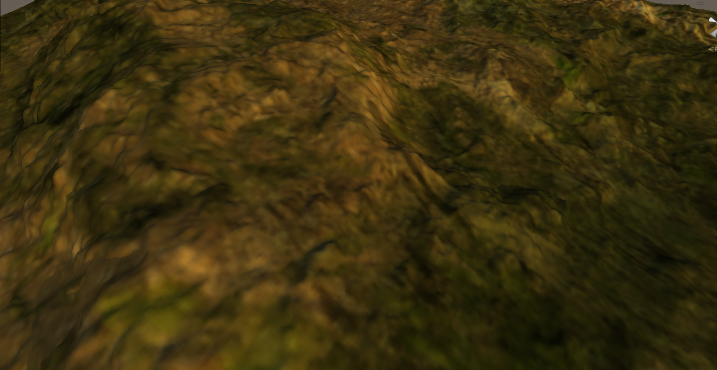

**Texture Shader**

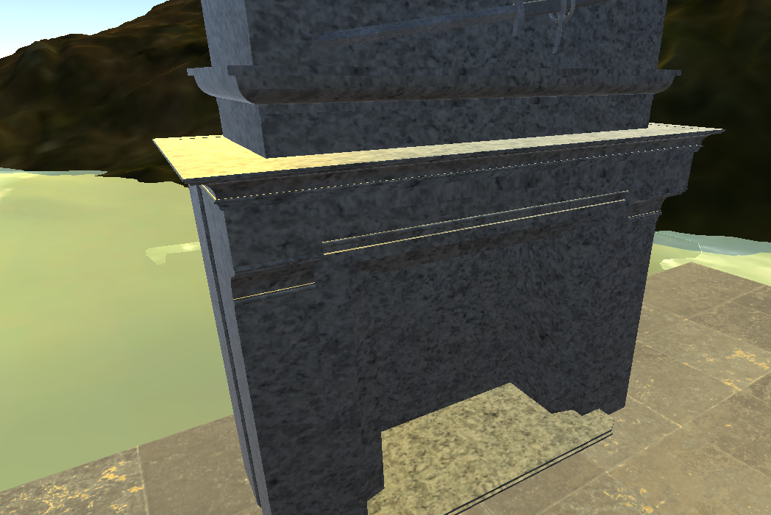

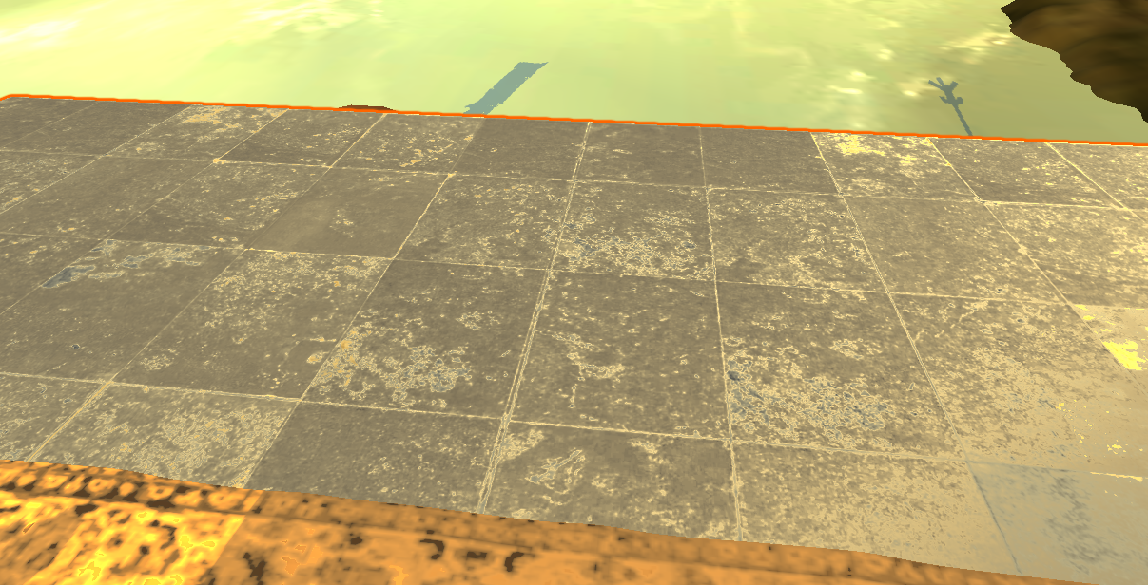**Surface Shader**

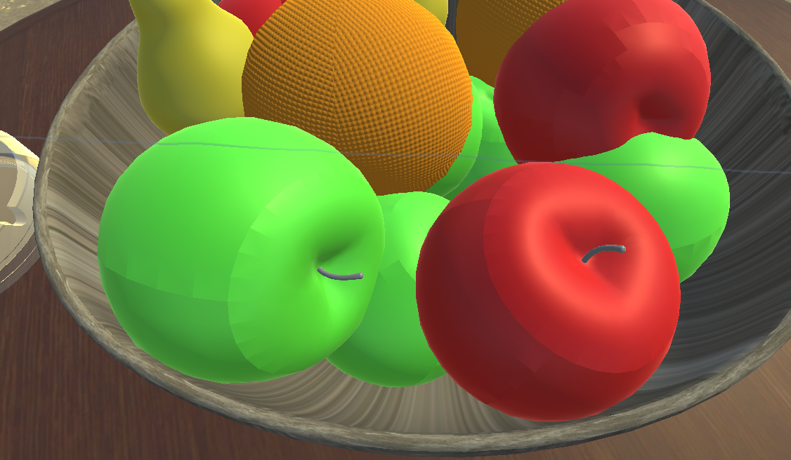

**Transparent Shader**

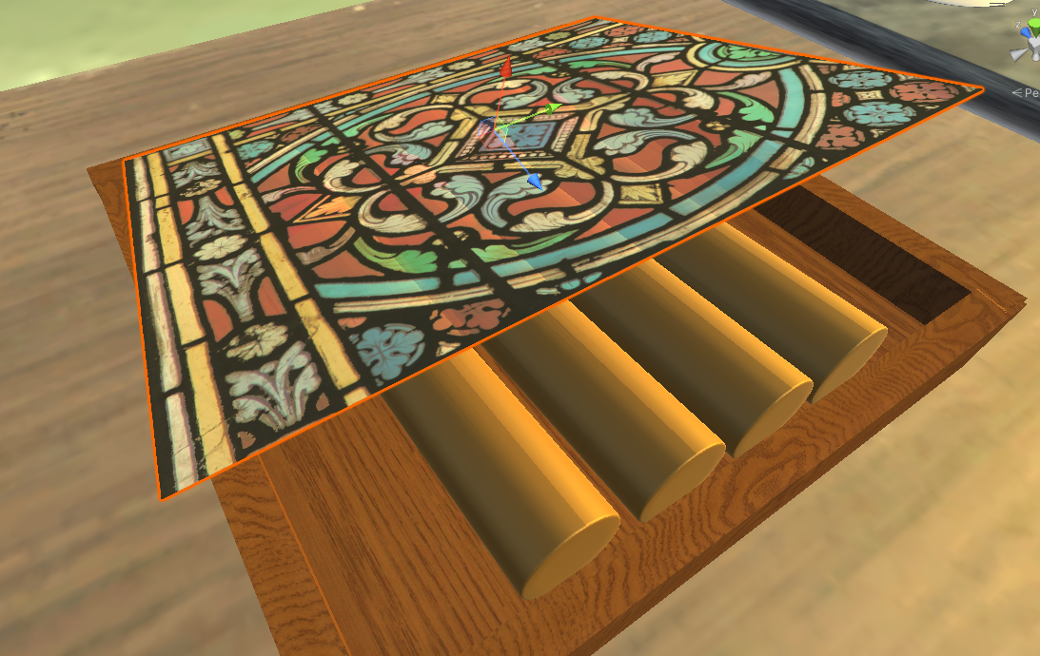

**UV Scrolling Shader**

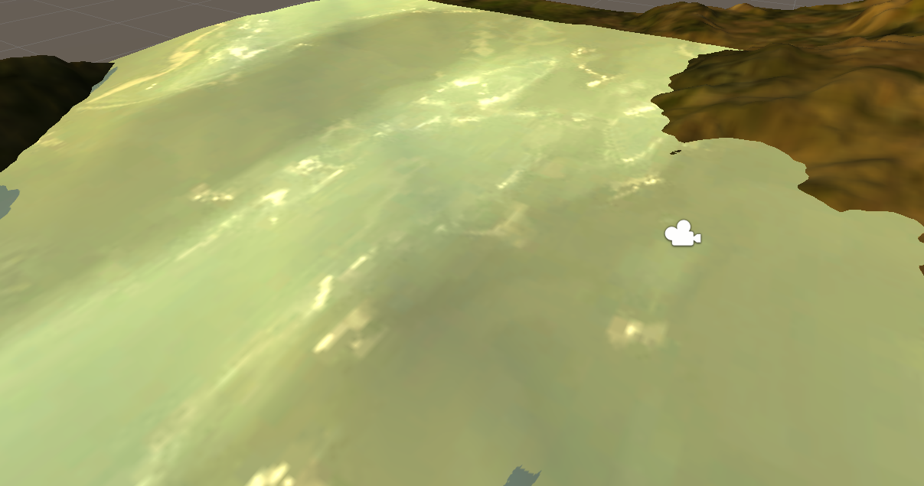

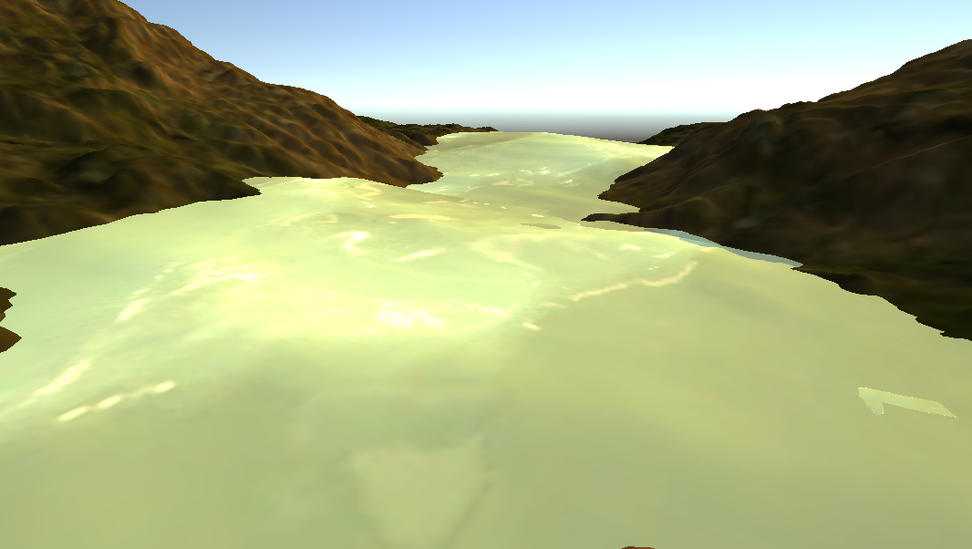

**Scene Screenshots**

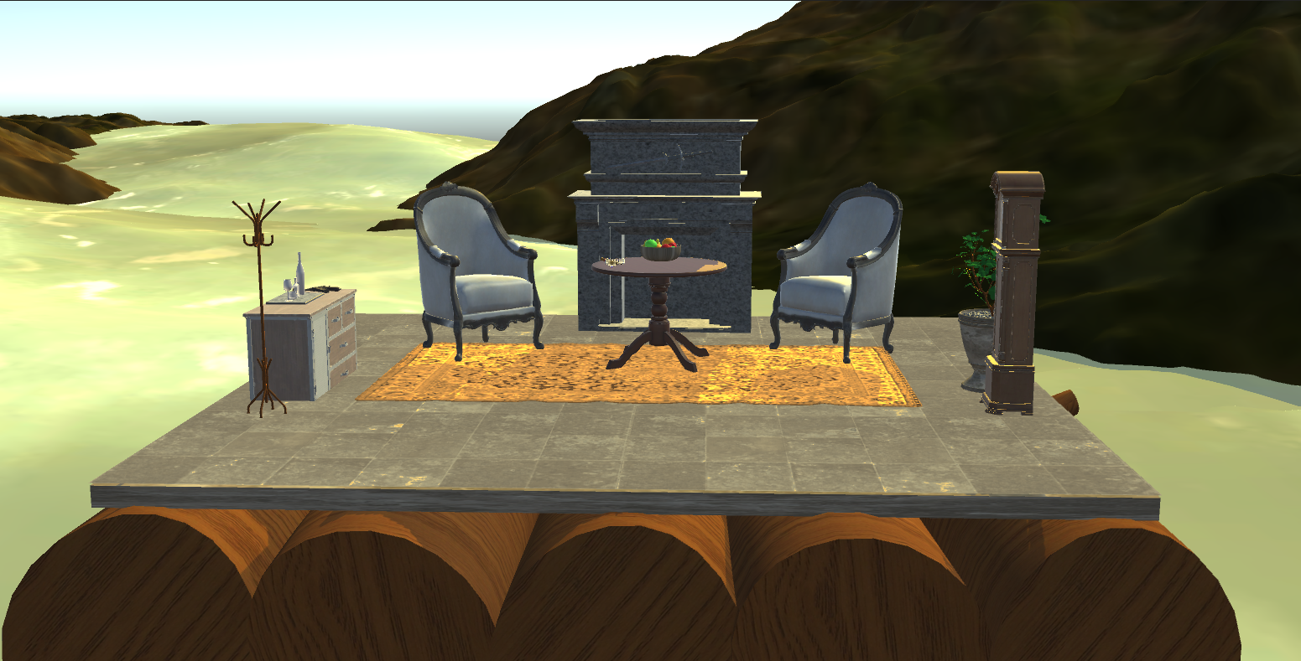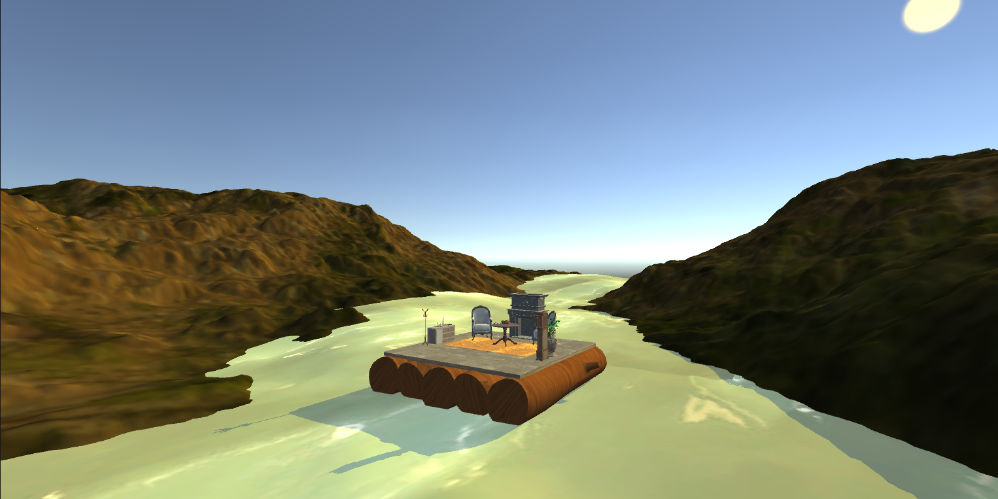

**Link to Demo Video**

https://youtu.be/nnp7Qi8Jv1w